Duke University School of Nursing
Instructions for Preparing CV in DUMC Curriculum Vitae Format

General Instructions:
- VERY IMPORTANT: Please be sure all publications, grants, memberships, etc. are accurately cited and up to date.
- This template includes a number of tables. If you cannot see the cell boundaries of the tables, please see Appendix A.
- Within any table, add or delete extra rows as needed
- Within all tables, list accomplishments in chronological order (oldest first).
- If you have no entries for a table, please delete that table.
First page:
- All underlining on this page may be deleted.
- The Primary academic appointment is the School of Nursing
- For secondary academic appointments (if any): a secondary academic appointment is granted by another Duke department/school in recognition of contributions to the department (teaching, service, research), typically at the same rank as the primary appointment. Indicate institution and/or school and (if appropriate) department.
- Nursing licensure: If licensed in additional state(s) other than North Carolina, licensure information for additional states may be provided on separate lines below the North Carolina licensure information.
- Specialty certification(s) and date(s): List certification, certifying body, initial year of issue, and expiration date (month/year). If no certifications, state “None”. Add lines for additional certifications as appropriate.
EDUCATION: List chronologically within each category (include post doctoral training).
SCHOLARLY SOCIETIES: (e.g., Sigma Theta Tau, Phi Beta Kappa, Sigma Xi.).
- Under “Date”, list year of induction into scholarly society.
- If no societies, enter “None” and delete this table.
PROFESSIONAL AND ACADEMIC CAREER. List positions chronologically, beginning with first position.
PUBLICATIONS – The tables in this section are provided for convenience. If preferred, numbered lists of publications may be substituted for these tables.
General comments about publications:
- Do not list publications in preparation.
- APA format is preferred. Do not use “et al” in the citation for authors – all authors should be listed for all publication types.
- Where applicable, provide PubMed ID numbers
- Where applicable, designate data-based publications with an asterisk (* = data-based)
- A published dissertation can be listed under non-refereed publications; an unpublished dissertation can be listed under other publications
- Publication categories include: 1) Refereed journals, 2) non-refereed publications, 3) chapters in books, 4) books, 5) non-authored publications, 6) other.
- Indicate senior authorship (using ** or other notation)
- Refereed journals are scientific publications that have active editorial boards and a system of critical review of all submissions for publication.
- Non-refereed publications refer to those which do not routinely use a system of critical review prior to publication; such articles are often solicited by the publisher.
- For books, indicate whether you are author or editor.
- For book chapters, include page numbers in each citation.
- Non-authored publications. Faculty who provide substantive contributions to large multi-institutional studies or reports may receive credit in the acknowledgments section of a resulting publication without being included on the list of authors (faculty member formally acknowledged in the publication for her/his contributions). Such publications can be listed in the “non-authored publication” category.
- The “other” category includes
a) published expert panel reviews, consensus statements, practice guidelines, or comparable reviews for mass distribution;
b) published abstracts (note if invited): the abstract should be published in a widely disseminated manner, beyond the conference proceedings/materials, either online or in print.
c) editorials, position papers, and background papers, and
d) distributed or disseminated works in other media (e.g., CDs, videos, training films, instructional software, patents, etc.)
- Within each category, please list publications chronologically and number them sequentially (#1 = oldest).
- If there are no publications in a category, enter “None at this time”. (If using the table format, delete the table for that category.)
- Within each category, publications that are “in press” and “submitted or in review” should be listed separately.
The table format provides optional “In press” and “Submitted or in review” subsections within categories 1-5.
- If using the table format, delete all table subsections that are not applicable.

MEDIA COVERAGE.
Media coverage may include online articles, features in newsletters, newspapers, magazines, and blogs or other online sources, radio and television interviews, etc. Group media coverage by category, and present items within each category in a numbered chronological list. (Avoid using tables in this section, because media coverage often includes links to URLs, which can distort the appearance of a table.)

PRESENTATIONS. Presentations with a published abstract should be listed in Publications section under Other, category b (published abstracts). Specify presentation type (e.g., podium presentation, poster, symposium, etc.).
Invited Presentations
- If desired, presentations may be grouped as international, national, regional, and/or local, with presentations should be listed in chronological order within each applicable category.
- Listings in this section should not be duplicated in “published abstracts”.
Other Presentations
- If desired, presentations may be grouped as international, national, regional, and/or local, with presentations should be listed in chronological order within each applicable category.
- Listings in this section should not be duplicated in “published abstracts”.

CONSULTANT APPOINTMENTS. Includes U.S. government, states, private organizations, etc.
- List organizations/institutions/agencies served, type of consulting done, and dates.

PROFESSIONAL AWARDS AND SPECIAL RECOGNITIONS. Includes internal and external honors, awards and distinctions (e g., FAAN, publications, teaching, etc. ) - include organization and dates

PROFESSIONAL ORGANIZATIONS AND PARTICIPATIONS. List organization, office held or committee assignment (if neither, specify “member”), and dates. Suggest listing alphabetically by organization and then service chronologically within the organization.

EDITORIAL BOARDS. Service as an editor or member of an editorial board. Identify journals, specific roles (editor or board member), and list dates.
- Service as a manuscript reviewer should be listed as a subcategory of this section.

REVIEW PANELS. If you have served on multiple types of review panels (review of journal manuscripts, conference abstracts, grant proposals, etc.), please group these separately.
- Within each grouping, list each review panel in chronological order (oldest first) and list dates of participation.

CLASSROOM AND ONLINE TEACHING.
- Teaching responsibilities at institutions previous to Duke and teaching responsibilities at Duke should be listed separately. Duplicate the table format as needed to provide a separate table for each institution.

CONTINUING EDUCATION. (e.g., workshops, seminars and instructional or educational programs).
- Include only CE activities which you taught
- Include location, audience, title of course, and date(s). If not applicable, state “None”, and delete the table.
GRADUATE AND POSTDOCTORAL SUPERVISION.
- Graduate supervision includes PhD dissertations, DNP capstone projects, and Master’s theses/projects.
- Provide separate lists (as applicable) for: Postdoctoral fellows/associates/mentees, PhD students, DNP students, and Master’s students. Tables are provided here for convenience; if preferred, numbered lists can be substituted for tables.
- Delete all categories that are not applicable. If your teaching responsibilities have not included graduate or postdoctoral supervision, enter “None” and delete all categories.
- Within each applicable category, list fellows or students chronologically and group them by institution.
- The listing for each graduate or postdoctoral supervisee should include the following information:
- Name • Academic institution • Research topic or title
- Dates: Year when supervision was initiated and year of degree completion (or “current”)
- Your supervisory role (committee chair or member, sponsor, mentor, etc.)

EXTERNAL FUNDING SECTION – Gifts, Grants and Contracts.
Enter all externally funded projects here. Separate sections are provided for:
- Research Support
- Educational/Training Support
- Other External Support (e.g., for implementation of community health programs, etc.)
If any of these sections is not applicable, enter “Not applicable”, and delete all tables for that particular section.
- Each section has three subsections which should be listed separately, in the following order:
- Present—Currently Active
- Pending (projects still under review)
- Past (projects that are no longer active).
If any of these subsections is not applicable, enter “Not applicable”, and delete the table for that particular subsection.
- Grants that were submitted and not funded should not be included.
- Provide a separate entry for each funded project. (Within each subsection, duplicate the project table as needed for additional entries.)
- Table details :
- Do not let any table break across pages; instead, insert a page break.
- Status on Grant: Identify your status on project (PI, Co-PI*, Project Director, Investigator, Mentor, Consultant, etc. * Co-PI is no longer recognized as a project/grant role by the NIH and should not be used as a status on NIH grants )
- Approved Project Period: Identify entire project period.
PARTICIPATION IN ACADEMIC AND ADMINISTRATIVE ACTIVITIES.
Activities and/or committee assignments at institutions previous to Duke.
- If applicable, administrative activities and committee assignments at academic, research, health care, and service institutions previous to Duke may be listed in this section. If reporting service to than one institution, provide a separate table for each institution. (Duplicate the table as appropriate.)
- If not applicable, delete this entire section, including the table.
Participation in academic and administrative activities at Duke.
- All activities, starting with DUSON activities, should be entered here. This includes past and present activities, listed in chronological order.
- Separate tables are provided for service to the School of Nursing, the Medical Center, and the University.
- If there are no activities, state “Not Applicable” and delete the table.

Instructions for adjusting Microsoft Word default setting so that you can see the cell boundaries of the tables are provided in Appendix A (pp. 6-7 below)

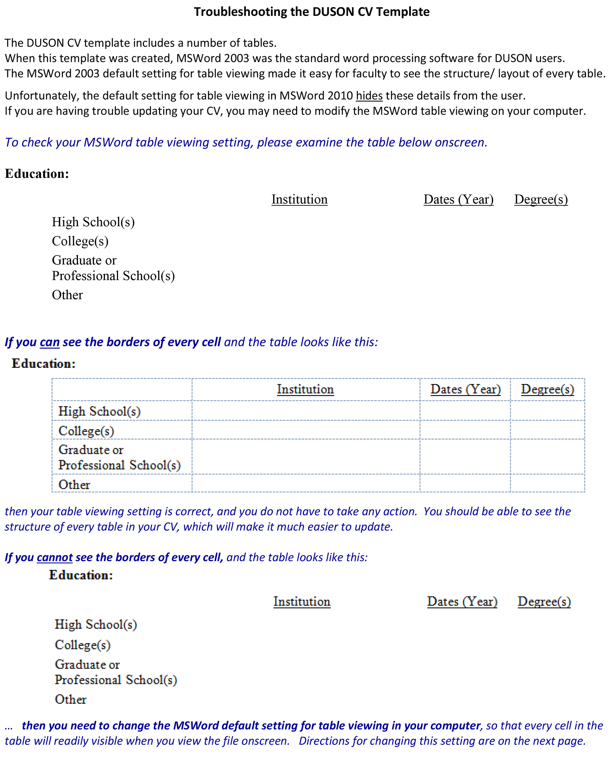
APPENDIX A
